

DIVINESECONDARYSCHOOL

MID TERM I EXAMINATIONS 2024

UGANDA CERTIFICATE OF LOWER EDUCATION

S.4 BIOLOGY PAPER 1

TIME; 2HOURS

* INSTRUCTIONS TO CANDIDATES
* ANSWER FOUR QUESTIONS
* ALL items carry equal scores
* Use of drawings or any illustrations will earn you scores

1. On a hot sunny day, the leaves of seedlings were seen wilted. However, at night, they recovered and regained their normal shape and size. A farmer noticed. He also noticed that all maize seedlings he planted in a water logged swamp expecting high yields were drying up.

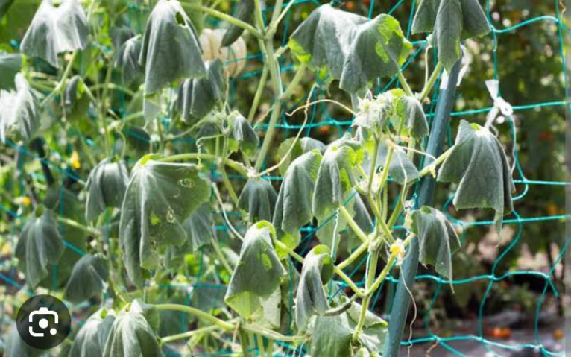

1. How can you best explain the phenomena to the farmer? (20scores)
2. In a school management committee meeting meeting at Divine ss kitala, members resolved to priotize learner’s health. They decided to include fish, fruits, and corn flour on the student’s menu on addition to posho and beans. Learners’ age and weight were also to be monitored while they were in school. All students using laxavitives and appetite-boosting drugs were to be suspended from school. This communication was to be presented by the Head prefect to the learners during the assembly held every Monday.

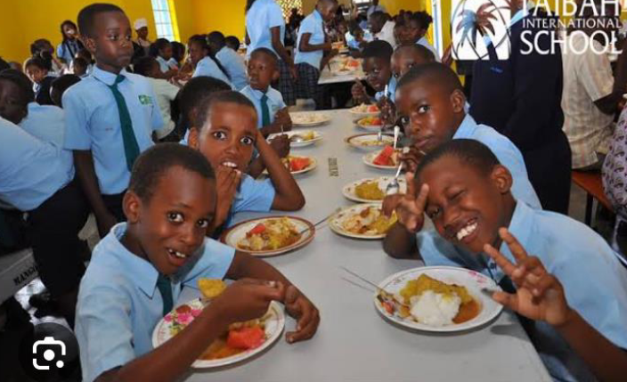

1. Assuming you were the Head prefect of Divine ss kitala, write an explanation you would give to the learners (20scores)
2. Ebonge Moses a senior four student while picking a piece of meat from the souce pan in the kitchen, he accidentally stepped on a hot piece of charcoal. He withdraws his leg immediately and he loudly cried out in pain. On checking his foot, he discovered that the wound formed was minimal and wondered how possible this was.



1. Why was Ebonge Moses surprised and able to escape from danger? (20 scores)
2. Divine ss kitala hosted some visitors from abroad last week. They came along with other native visitors who were hosted by the former director Madam Tabaro. They narrated their life journey which wasn’t pleasing at all. One of the side he was a drug abuser and dealer whereby he killed many people during his life because of drug abuse. He advised the young youth and the school going children to always avoid drug abuse if they want to live a pleasant life.

He supported his words by even explaining the effects of drug abuse to the society.

**SUPPORT MATERIAL;**

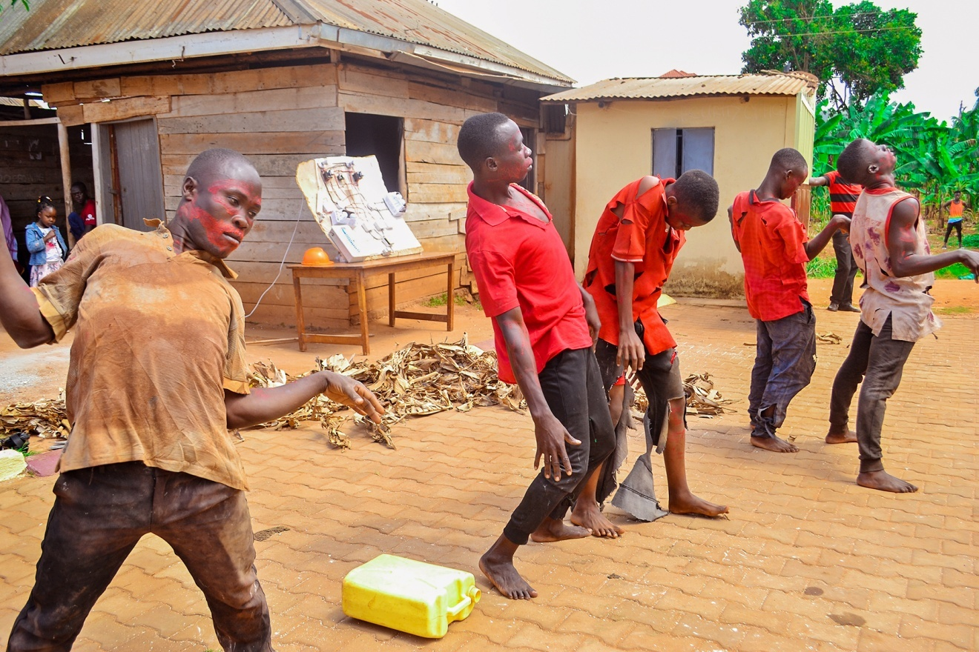

TASK;

Emmanuela a S.1 student approached you to enlight her about the effects of drug abuse in the society because she couldn’t understand properly the English spoken by the invited guest.

Write an essay explaining Emmanuella the effects, causes and ways of preventing drug abuse in the society. (20 scores)

1. A 12 year old girl from Divine ss kitala in S.1 approached you. She was concerned/worried about changes in her body. She had developed breasts, was growing very tall, had pimples, irregular menstrual periods and hips. She is hyperactive, sweats and passes a lot of urine. She also told you that she should have a boyfriend. She as well told that most of her friends had similar changes and felt the same way



**TASK;** Write the talk that you will give to the members of the youth club. (20 SCORES)

**END**